

ThttLiteracy 
PE:
Mekong: Wednesday

TRIPS:
British Museum – Date TBC

Geography:
Farming

Literacy:
Focus Text:
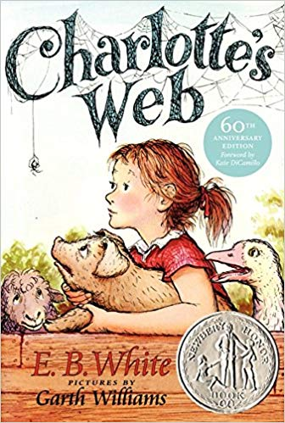
Diary entries
Fact files
Balanced arguments
Grammar
Write extended sentences using a range of coordinating (and, but, or) and subordinating conjunctions (because, when, if, after, while, although etc.).

Use apostrophes for omission and possession, including in regular and irregular plurals

To use commas to separate clauses in a sentence.

PSHE:
Health and Wellbeing:
How can we manage our feelings?

Computing:
Creating Media
Website Design

Spanish:
Vamonos - Let's go
DT:
Electrical Components
Torch


RE:
Sikhism
Wisdom

Science:
Animals, including humans - Food Chain 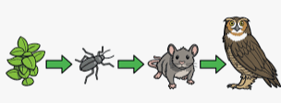

Mathematics:

- Revise arithmetic.
- Extend number sequences counting on or back in different steps including using multiplication and division.
- Check my answers using estimation and inverse operations.
- Find area and perimeter of shape.
- Interpret data on bar graphs and line graphs
- Plot points on a 2D grid in the first quadrant.

Edward Wilson School Spring 1 Year 4
Curriculum Overview for Parents and Guardians

