
ThttLiteracy 
PSHE:
- What decisions can people make with money?

RE:
Rituals
(Christianity- Paschal Candle)
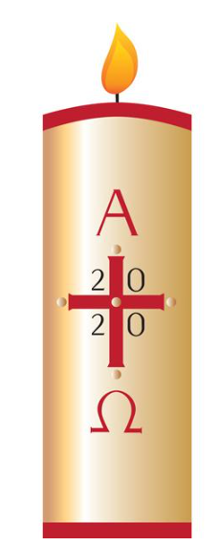
Art:
Mayan Mask
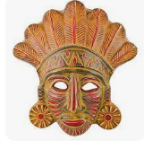

Mathematics:
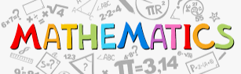
- Divide and multiply numbers- including decimal numbers- by 10 and by 100 and 1000
- Measurements: Length, capacity, weight.
- Word problems involving money and measures.
- Solve problems that involve subtracting whole numbers and decimals.
- Identify and estimate number using different representations
- Factors and multiples
- Inverses and division.

Literacy:
Focus Text:
Literacy
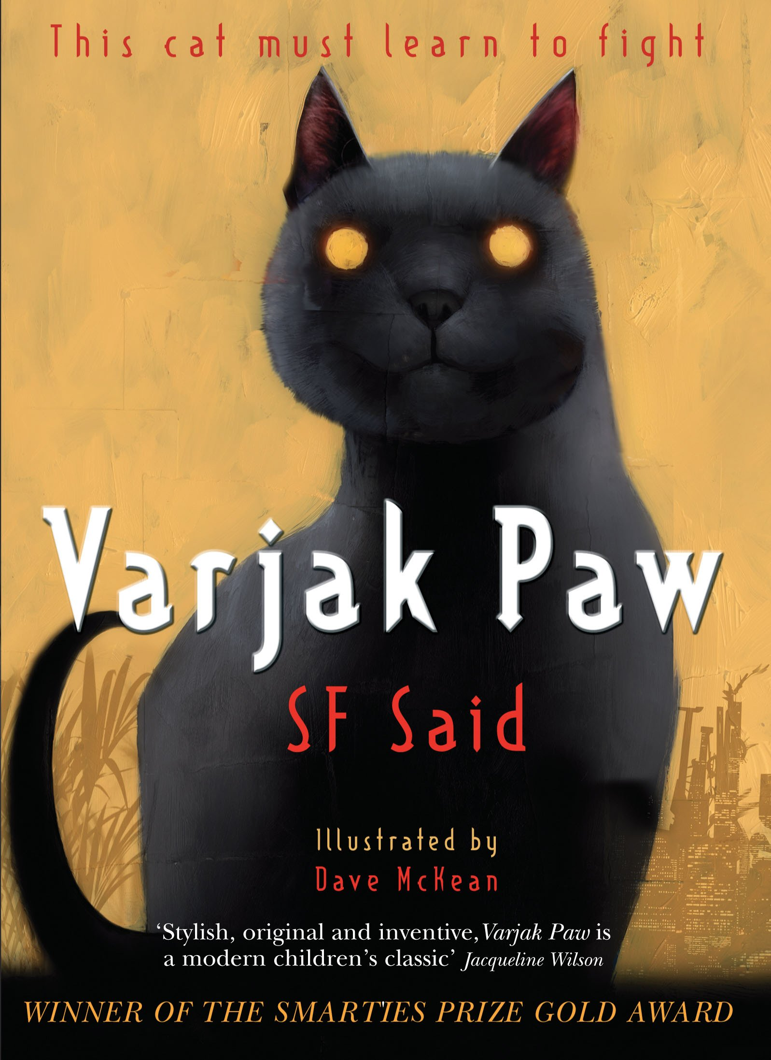
Key writing tasks:
Diary entries.
News report.
Character narrative
Vocabulary, grammar and punctuality focus:
- Direct speech punctuation
- Pronouns and synonyms for cohesion.
- Prepositional phrases
- Plural possessives – -s / -es

TRIPS:
British Museum -TBC
Paddington Urban Farm - TBC

PE
Mekong: PE on Wednesdays and swimming on Fridays

History:
The Maya Civilisation
Computing:
Creating Media
Website Design

Music:
Recorder, Sticks and Songs by Sally Graves
Science:
Teeth and Digestive System
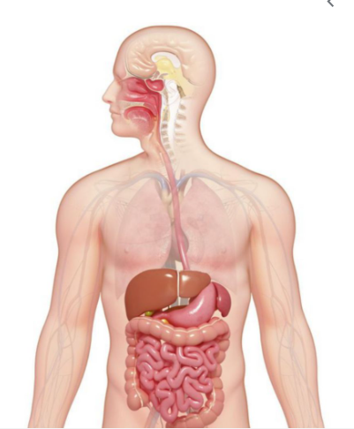
Edward Wilson School Spring 2 Year 4
Curriculum Overview for Parents and Guardians

