ThttLiteracy 
Computing:
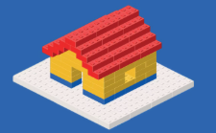
Programming- Computational thinking

PE
Mekong: PM Friday – Swimming

Literacy:
Focus Text:
Literacy
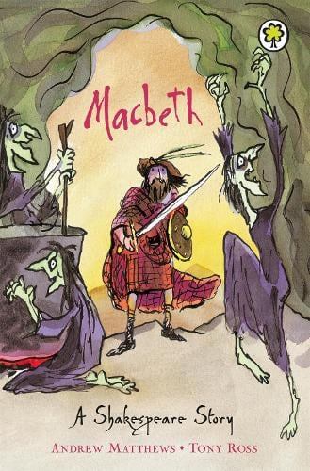
Key writing tasks:
Play script
Diary
Newspaper report
Vocabulary, grammar and punctuality focus:
- Homophones
- Pronouns for cohesion
- Stage directions
- Direct and indirect speech

TRIPS:
30th April 2026
Floating classroom-Climate champions

RE:
Identity
(Mezuzah and Shema)
DT:
Textiles – Making Varjak Paw puppets

Mathematics:


- Word problems involving addition and subtraction
- Checking answers using rounding
- Timestable assessment preparation
- Coordinates
- Describing movements between positions as translations
- Converting time
- Compass and cardinal points


Geography:
Rivers and the Water Cycle

PSHE:

- Mekong: What decisions can people make with money?
Music:

Science:
Sound
Edward Wilson School Summer 1 Year 4
Curriculum Overview for Parents and Guardians

